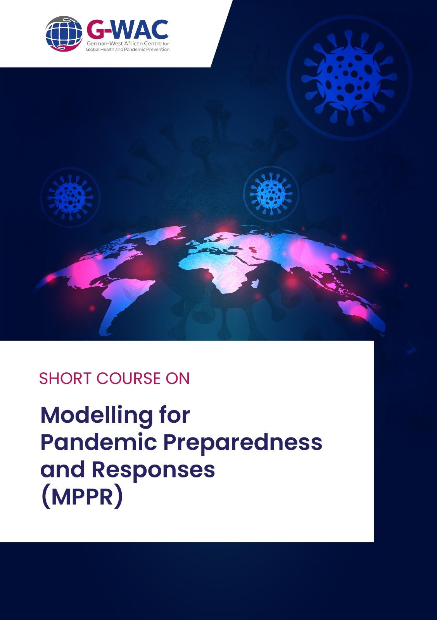

Modular Certificate Course on
Modelling for Pandemic Preparedness and Responses (MPPR)

Course Outline:
1ST – 1O^{TH} September 2025 | In-person Session at KNUST, Kumasi

Key partners:















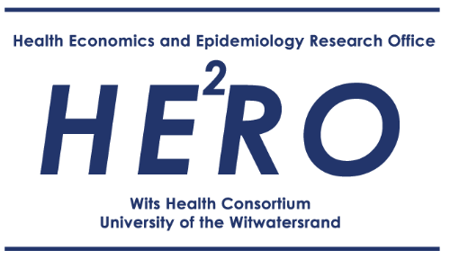





…Other collabo ra tors:
Introduction
The German-West African Centre (G-WAC) for Global Health and Pandemic Prevention hosted at the Kwame Nkrumah University of Science and Technology (KNUST), Kumasi, Ghana is offering this modular short course on Modelling for Pandemic Preparedness and Response (MPPR). The course is designed and implemented by G-WAC - a cooperation between the KNUST, Berlin School of Public Health (with Technische Universität Berlin and Charité Universitätsmedizin Berlin) and University Hospital Bonn (and University of Bonn). G-WAC and the MPPR short course is supported by the German Academic Exchange Service (DAAD) with funding from the budget of the German Federal Foreign Office, Project ID: 57592595.

Course Description
The emergence of the COVID-19 pandemic highlighted the lack of disease modelling capacity in many low-or middle-income countries (LMICs) including sub-Saharan Africa (SSA). In SSA, limitations of data and the generalised nature of globally produced models for pandemics weakens their utility and raises concerns over their accuracy. The availability of high-quality modelling evidence to inform decisions and the capacity of policymakers to use this evidence is therefore critically important. Additionally, modelling expertise is not only of value in epidemic/pandemic contexts but can play an important role in the management of endemic diseases. The course will introduce participants to the concept of modelling and their applicability in Ghana and other similar settings in Africa. Course content will be delivered through teaching and hands-on exercises to give the participants a comprehensive training on modelling.

As a modular course, the Modeling for Pandemic Preparedness and Response (MPPR) course is organized into two parts:

Part I: Essentials of Disease Modelling
Part II: Modelling for Pandemic Preparedness and Response
Course Objectives/Learning Outcomes
At the end of the course, participants will be able to:
- Understand the concepts of infectious-disease transmission and control.
- Enhance knowledge about data sources, data access, and data curation in (West) Africa.
- Design, implement and use context-specific mathematical models, using the R programming language.
- Improve knowledge of communication about modeling output.
- Become part of a network of disease modelers with an interest in West Africa.

Target Participant
The course is targeted at interdisciplinary participants with strong quantitative background (at least a master’s degree or equivalent work experience) in mathematics, econometrics, epidemiology, data science, biomedical sciences, or other relevant disciplines.

Certification
Upon successfully completing BOTH course modules, participants will be awarded a certificate issued by KNUST which is accredited for Continuous Professional Development (CPD) points and may be applicable to individuals who are members of or are associated with (health) professional bodies in Ghana or elsewhere.

Course Outline
The course is a 9 days intensive in-person training hosted at the KNUST, Kumasi, Ghana. Part I of the course covers an estimated total workload of 24 hours, running over three (3) days, starting from 1st to 3rd September 2025. Part II covers a workload of 48 hours, running over 6-days from 4 to 10 September 2025, culminating in a pre−conference workshop at G-WAC’s final conference, organized in collaboration with the KNUST College of Health Sciences annual conference, and a launch event for a network of West African modellers.
Part I: Essentials of Disease Modelling
The course module will introduce participants to the concept of modelling and its applicability.

DATE / TIME | MAIN TOPICS | FACILITATORS
Monday  1st September 2025  09:00 AM  –  12:00 PM GMT | Introduction to the German West-African Centre for Global Health and Prevention (G-WAC) | Main: John Amuasi
 | - Crash course in R programming (Writing R functions, Basics of the deSolve R package, Writing ODE systems in R, Optimisation, Debugging/profiling R code, writing efficient R code) | Main: James Azam  Supports: Vincent Donkoh, Others TBD
12:00 PM  –  1:30 PM GMT | Lunch break
1:30 PM  GMT  –  5:00 PM GMT | - Introduction to version control using git and GitHub  - Using R with git & GitHub.  - Best practices for reproducible scientific computing | Main: Vincent Donkoh  Supports: James Azam, TBD
6:00 PM | Dinner & Socials (Paa Joe)
Tuesday  2nd September 2025  09:00 AM  –  12:00 PM GMT | Basics of infectious disease modeling  - An overview of infectious diseases and control measures  - Basics of constructing mathematical models (SIR, SEIR, SEIRV)  - Understanding/ calculating the basic reproduction number (R0) | Main: Jean Claude Dejon Agobé and James Azam  Supports: Vincent Donkoh & TBG
12:00 PM  –  1:30 PM GMT | Lunch break
1:30 PM  –  5:00 PM GMT | Basics of infectious disease modeling (cont’d)  - Basics of constructing mathematical models (SIR, SEIR, SEIRV)  - Understanding/ calculating the basic reproduction number (R0)  Exercises on:  Overview of infectious diseases and control measures & Basics of infectious disease modeling | Exercise Supervision: Jean Claude Dejon Agobé, James Azam, Vincent Donkoh, Andrzej Jarynowski, Charlène Naomie Tedto Mfangnia
18:00 PM | Dinner & Socials
Wednesday  3rd September 2025  09:00 AM  –  12:00 PM GMT | Basics of infectious disease modeling:  - Introduction to model simulation in R (odin & monty)  - Understanding model outputs | Main: Vincent Donkoh  Supports: James Azam, Jean Claude Dejon Agobé, Andrzej Jarynowski, Charlène Naomie Tedto Mfangnia
12:00 PM  –  1:30 PM GMT | Lunch break
1:30 PM  –  05:00 PM GMT | Extending the SIR model:  - Age structure, different risk profiles, metapopulations, and multi-host models.  - Adding stochasticity  - Model simulation and interpretation in R.  Assignments on extending the SIR model.  Discussion | Exercise Supervision: Dr. Daniel Boateng, James Azam, Vincent Donkoh
6:00 PM | Dinner & Socials

Part II: Advanced disease modelling for pandemic preparedness and response (IN-PERSON)
The aim is to equip participants with practical skills in disease modelling for pandemic preparedness and response. Course content will be delivered mainly through hands-on exercises to give the participants a comprehensive training on modelling. A crash course in R will be offered to further introduce participant to writing R functions, basics of the deSolve R package, writing ODE systems in R etc.

DATE / TIME | MAIN TOPICS | FACILITATORS
Thursday  4th September 2025  09:00 AM  –  12:00 PM GMT | Basics of model calibration/ fitting/ validation techniques:  - Data sources and data curation (discussion):  - Types of data needed to inform different models  - Challenges in identifying and accessing data  - Data and metadata standards  - Combining and curating different data sources  - Sources of bias in data collection, access, and use  - Overview of common model fitting approaches: Least squares, Direct curve, Grid search, Maximum likelihood estimation, MCMC, and Approximate Bayesian Computation  Discussion | Main: James Azam  Supports: Vincent Donkor, Andrzej Jarynowski, Jean Claude Dejon Agobé, Andrzej Jarynowski, Charlène Naomie Tedto Mfangnia
12:00 PM  –  1:30 PM GMT | Lunch break
1:30 PM  –  5:00 PM GMT | Basics of model calibration/ fitting/ validation techniques:  - Implementation of common methods using R and R packages. | Exercise Supervision: James Azam, Vincent Donkoh, Jean Claude Dejon Agobé, Charlène Naomie Tedto Mfangnia
6:00 PM | Dinner & Socials
Friday  5th September 2025  09:00 AM  –  12:00 PM GMT | Overview of scenario modeling  - Understanding the relevance of scenario modelling and sensitivity analyses to quantify uncertainty in the parameters and outcomes  Mini-seminar on scenario modeling in practice (1 hour; Gesine Meyer-Rath)  - A case study of COVID-19 in South Africa  Exercise on scenario modeling | Main: Andrzej Jarynowski  Supports: James Azam, Vincent Donkoh, and Jean Claude Dejon Agobé, Charlène Naomie Tedto Mfangnia
12:00 PM  –  1:30 PM GMT | Lunch break
1:30 PM  –  5:00 PM GMT | Incorporating health economics into epidemic models  - Budgets and resource quantification  - Cost analysis  - Economic evaluation (cost-effectiveness analysis, cost-outcome analysis)  - Overview of last year’s projects:  - Modeling of Mpox | Main: TBD  Supports: Andrzej Jarynowski, James Azam, Vincent Donkoh, and Jean Claude Dejon Agobé, Charlène Naomie Tedto Mfangnia
6:00 PM | Dinner & Socials
Saturday  6th  September 2025  09:00 AM  –  12:00 PM GMT | Science and Policy Communication in the context of modelling  - Learn the basics of science communication  - Tools for communication  - Data visualisation preferences, including dashboards  Group projects (allocations & overview)  - This year’s projects:  - COVID-19 in West Africa (Andrzej)  - Malaria spread under vaccination (James)  - Schistosomiasis scenario analysis (Jean Claude) | Main: Daniel Opoku & Daniel Boateng (TBD)  Supervision: James Azam, Andrzej Jarynowski, Vincent Donkoh, Jean Claude Dejon Agobé, Charlène Naomie Tedto Mfangnia
12:00 PM  –  1:30 PM GMT | Lunch break
1:30 PM  –  5:00 PM GMT | - Socials
6:00 PM | Dinner & Socials
Monday  8th  September 2025  09:00 AM  –  12:00 PM GMT | Group projects  - Options:  - COVID-19 in West Africa  - Malaria spread under vaccination  - Schistosomiasis scenario analysis | Supervision: James Azam, Andrzej Jarynowski, Vincent Donkoh, Jean Claude Dejon Agobé, Charlène Naomie Tedto Mfangnia
12:00 PM  –  1:30 PM GMT | Lunch break
1:30 PM  –  5:00 PM GMT | Group projects  - Options:  - COVID-19 in West Africa  - Malaria spread under vaccination  - Schistosomiasis scenario analysis | Supervision: James Azam, Andrzej Jarynowski, Vincent Donkoh, Jean Claude Dejon Agobé, Charlène Naomie Tedto Mfangnia
6:00 PM | Dinner & Socials
Tuesday  9th  September 2025  09:00 AM  –  12:00 PM GMT | Group projects  - Options:  - COVID-19 in West Africa  - Malaria spread under vaccination  - Schistosomiasis scenario analysis | Supervision: James Azam, Andrzej Jarynowski, Vincent Donkoh, Jean Claude Dejon Agobé, Charlène Naomie Tedto Mfangnia
12:00 PM  –  1:30 PM GMT | Lunch break
1:30 PM  –  5:00 PM GMT | Group projects  - Options:  - COVID-19 in West Africa  - Malaria spread under vaccination  - Schistosomiasis scenario analysis | Supervision: James Azam, Andrzej Jarynowski, Vincent Donkoh, Jean Claude Dejon Agobé, Charlène Naomie Tedto Mfangnia
6:00 PM | Dinner & Socials
Wednesday  10th  September 2025  09:00 AM  –  12:00 PM GMT | Group projects  - Options:  - COVID-19 in West Africa  - Malaria spread under vaccination  - Schistosomiasis scenario analysis  Discussion | Supervision: James Azam, Andrzej Jarynowski, Vincent Donkoh, Jean Claude Dejon Agobé, Charlène Naomie Tedto Mfangnia
12:00 PM  –  1:30 PM GMT | Lunch break
1:30 PM  –  5:00 PM GMT | - Pre-conference workshop  - Group presentations
5:30 PM  -  8:00 PM | Network of Modelers for Pandemic Preparedness and Response (G-WAC MPPR Network) | Host: Daniel Boateng & Daniel Opoku

G-WAC NETWORK OF
MODELERS FOR PANDEMIC PREPAREDNESS AND RESPONSE

G-WAC invites you to the launching of a Network of Modelers for Pandemic Preparedness and Response (G-WAC MPPR Network). This network is to collaborate and contribute high-quality modelling evidence to inform decisions in the management of epidemics and pandemics as well as endemic diseases in Africa. Join us on Wednesday 10th September 2025, from 5:30 PM – 8:00 PM GMT for this launching and networking event.

LAUNCHING AND NETWORKING EVENT

WEDNESDAY 10TH SEPTEMBER 2025

5:30 PM – 8:00 PM GMT


- REGISTRATION

- WELCOME

- OPENING REMARK

- LAUNCH - TOASTMASTER

- INNAUGURAL CEREMONY

- ROUND-TABLE DISCUSSION

- INTERACTIVE SESSION

- DINNER

- PHOTO SESSION

- DEPARTURE

SPECIAL GUESTS: PROF. CHRISTIAN AGYARE, PROVOST, CHS, KNUST

HOST: DR. DANIEL BOATENG & DR. DANIEL OPOKU

THANK YOU.
Course Facilitators
Dr. James Azam
London School of Hygiene and Tropical Medicine

Dr. Andrzej Jarynowski
Department of Veterinary Medicine, Freie Universität Berlin

Vincent Donkoh
Kwame Nkrumah University of Science and Technology, Kumasi

Dr. Jean Claude Dejon Agobé
Centre de Recherches Médicales de Lambaréné

Prof. Gesine Meyer-Rath
Health Economics and Epidemiology Research Office, Boston University / University of Witwatersrand

Charlène Naomie Tedto Mfangnia
International Centre of Insect Physiology and Ecology

Dr. Daniel Boateng
Kwame Nkrumah University of Science and Technology, Kumasi

Dr. Daniel Opoku
Kwame Nkrumah University of Science and Technology, Kumasi

Vincent Findeiss
Technical University of Berlin

For G-WAC MPPR Modular Course specific enquiries, please contact:

Vincent Findeiß, Coordinator, G-WAC, Berlin; vincent.findeiss@tu-berlin.de
Dr. Daniel Opoku, Coordinator, G-WAC, Kumasi; danielkojopoku@gmail.com
Dr. Daniel Boateng, Coordinator, G-WAC, Kumasi; daniel.dboateng@gmail.com
Prof. Wilm Quentin, Project Lead & Co-Director, G-WAC, Berlin; wilm.quentin@tu-berlin.de
Dr. John Amuasi, Ag. Director, G-WAC, Kumasi; amuasi@kccr.de
Prof. Walter Bruchhausen, Co-Director, G-WAC, Bonn; Walter.Bruchhausen@ukbonn.de
Patricia Matey-Akuffo, Project Manager, G-WAC, Kumasi; pmatey.akuffo@g-wac.org

For any further enquiries, please contact:
Ghana Office
G-WAC Secretariat
Kwame Nkrumah University of Science and Technology,
Private Mail Bag (PMB)
Kumasi Campus,
Kumasi, GHANA.
Email: info@g-wac.org
Website: www.g-wac.org
Germany Office
Technische Universität Berlin (TU Berlin)
International Projects
Department of International Affairs
Sek. INT IP, Room: H 2022
Strasse des 17. Juni 135, 10623 Berlin
GERMANY.
Email: g.wac@international.tu-berlin.de


©2025

